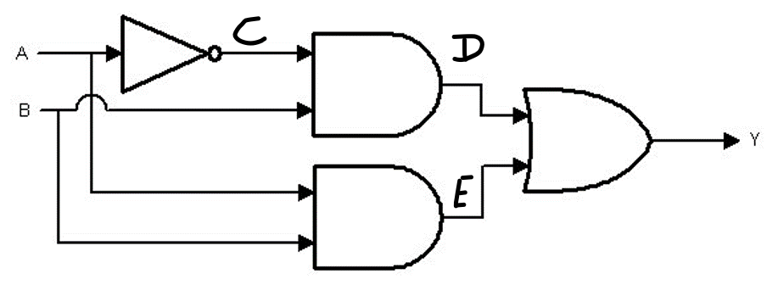

|  |  |  |  |  |  |
| --- | --- | --- | --- | --- | --- |
| A | B | C | D | E | Y |
| 0 | 0 | 1 | 0 | 0 | 0 |
| 0 | 1 | 1 | 1 | 0 | 1 |
| 1 | 0 | 0 | 0 | 0 | 0 |
| 1 | 1 | 0 | 0 | 1 | 1 |

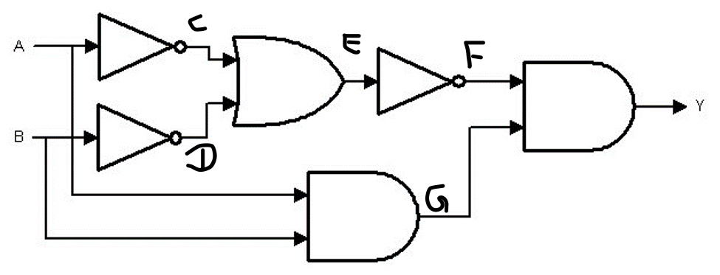

|  |  |  |  |  |  |  |  |
| --- | --- | --- | --- | --- | --- | --- | --- |
| A | B | C | D | E | F | G | Y |
| 0 | 0 | 1 | 1 | 1 | 0 | 0 | 0 |
| 0 | 1 | 1 | 0 | 1 | 0 | 0 | 0 |
| 1 | 0 | 0 | 1 | 1 | 0 | 0 | 0 |
| 1 | 1 | 0 | 0 | 0 | 1 | 1 | 1 |

Convert 110101 from Binary to Decimal

|  |  |  |  |  |  |
| --- | --- | --- | --- | --- | --- |
| 1 | 1 | 0 | 1 | 0 | 1 |
| 32 | 16 | 8 | 4 | 2 | 1 |
| $$2^{5}$$ | $$2^{4}$$ | $$2^{3}$$ | $$2^{2}$$ | $$2^{1}$$ | $$2^{0}$$ |

32+16+4+1 = 53

**53**

Convert 98 from Decimal to Binary

|  |  |  |  |  |  |  |
| --- | --- | --- | --- | --- | --- | --- |
| 1 | 1 | 0 | 0 | 0 | 1 | 0 |
| 64 | 32 | 16 | 8 | 4 | 2 | 1 |
| $$2^{6}$$ | $$2^{5}$$ | $$2^{4}$$ | $$2^{3}$$ | $$2^{2}$$ | $$2^{1}$$ | $$2^{0}$$ |

98-64 = 34-32 = 2-2 = 0

**01100010**

Convert 534 from Decimal to Hexa

|  |  |  |
| --- | --- | --- |
| 2 | 1 | 6 |
| 256 | 16 | 1 |
| $${16}^{2}$$ | $${16}^{1}$$ | $${16}^{0}$$ |

534 – 2(256) = 22 – 1(16) = 6 – 6(1) = 0

**216**

Convert 1FA from Hexa to Decimal Conversion

|  |  |  |
| --- | --- | --- |
| 1 | F | A |
| 256 | 16 | 1 |
| $${16}^{2}$$ | $${16}^{1}$$ | $${16}^{0}$$ |

1(256) + 15(16) + 10(1) = 506

**506**